MapReduce WordCount Program
=================================================================================
(Step-1: File->New->Java Project->Give Name of the Project->press Finish Button.
Step-2: Right Click on “src” which is in Package Explorer tab -> Click On “Build Path”->Configure Build Path->Click on Libraries tab->Add
External JARs..->Press “Ok” Button.
Step-3: Right Click on “src” ->New->Class->give the name of Class File same as in code->Press “Finish” Button->Paste Code/Write the Code
Step-4: Again Right Click on “src”->Export->Select JAR File under the Java->give the path as well as Name of JAR File->Press Finish
Button
Step-5: Copy JAR File in MapReduce Folder -> Next Step in VMware…
)
================================================================================================

mrinmoy@ubuntu:~$ su
Password:
root@ubuntu:/home/mrinmoy# cd /
root@ubuntu:/# hadoop fs -mkdir /Deepak_Word_Count/

root@ubuntu:/# cp home/mrinmoy/Downloads/GOPAL/Input-Big.txt .
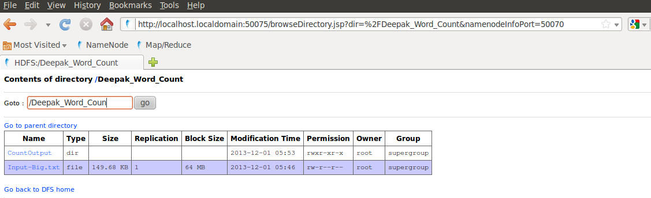

root@ubuntu:/# hadoop fs -put Input-Big.txt /Deepak_Word_Count/

root@ubuntu:/# cd home/mrinmoy/Downloads/MapReduce

root@ubuntu:/home/mrinmoy/Downloads/MapReduce# hadoop jar WordCount.jar WordCountNew /Deepak_Word_Count/Input-Big.txt /Deepak_Word_Count/CountOutput

13/12/01 05:51:46 WARN mapred.JobClient: Use GenericOptionsParser for parsing the arguments. Applications should implement Tool for the same.
13/12/01 05:51:48 INFO input.FileInputFormat: Total input paths to process : 1
13/12/01 05:51:48 WARN snappy.LoadSnappy: Snappy native library is available
13/12/01 05:51:48 INFO util.NativeCodeLoader: Loaded the native-hadoop library
13/12/01 05:51:48 INFO snappy.LoadSnappy: Snappy native library loaded
13/12/01 05:51:53 INFO mapred.JobClient: Running job: job_201312010239_0001
13/12/01 05:51:54 INFO mapred.JobClient: map 0% reduce 0%
13/12/01 05:53:01 INFO mapred.JobClient: map 100% reduce 0%
13/12/01 05:53:32 INFO mapred.JobClient: map 100% reduce 100%
13/12/01 05:53:33 INFO mapred.JobClient: Job complete: job_201312010239_0001
13/12/01 05:53:33 INFO mapred.JobClient: Counters: 26
13/12/01 05:53:33 INFO mapred.JobClient: Job Counters
13/12/01 05:53:33 INFO mapred.JobClient: Launched reduce tasks=1
13/12/01 05:53:33 INFO mapred.JobClient: SLOTS_MILLIS_MAPS=61782
13/12/01 05:53:33 INFO mapred.JobClient: Total time spent by all reduces waiting after reserving slots (ms)=0
13/12/01 05:53:33 INFO mapred.JobClient: Total time spent by all maps waiting after reserving slots (ms)=0
13/12/01 05:53:33 INFO mapred.JobClient: Launched map tasks=1
13/12/01 05:53:33 INFO mapred.JobClient: Data-local map tasks=1
13/12/01 05:53:33 INFO mapred.JobClient: SLOTS_MILLIS_REDUCES=30461
13/12/01 05:53:33 INFO mapred.JobClient: FileSystemCounters
13/12/01 05:53:33 INFO mapred.JobClient: FILE_BYTES_READ=139
13/12/01 05:53:33 INFO mapred.JobClient: HDFS_BYTES_READ=153388
13/12/01 05:53:33 INFO mapred.JobClient: FILE_BYTES_WRITTEN=119176
13/12/01 05:53:33 INFO mapred.JobClient: HDFS_BYTES_WRITTEN=122
13/12/01 05:53:33 INFO mapred.JobClient: Map-Reduce Framework
13/12/01 05:53:33 INFO mapred.JobClient: Map input records=5487
13/12/01 05:53:33 INFO mapred.JobClient: Reduce shuffle bytes=139
13/12/01 05:53:33 INFO mapred.JobClient: Spilled Records=22
13/12/01 05:53:33 INFO mapred.JobClient: Map output bytes=251174
13/12/01 05:53:33 INFO mapred.JobClient: CPU time spent (ms)=48720
13/12/01 05:53:33 INFO mapred.JobClient: Total committed heap usage (bytes)=102367232
13/12/01 05:53:33 INFO mapred.JobClient: Combine input records=25872
13/12/01 05:53:33 INFO mapred.JobClient: SPLIT_RAW_BYTES=118
13/12/01 05:53:33 INFO mapred.JobClient: Reduce input records=11
13/12/01 05:53:33 INFO mapred.JobClient: Reduce input groups=11
13/12/01 05:53:33 INFO mapred.JobClient: Combine output records=11
13/12/01 05:53:33 INFO mapred.JobClient: Physical memory (bytes) snapshot=262885376
13/12/01 05:53:33 INFO mapred.JobClient: Reduce output records=11
13/12/01 05:53:33 INFO mapred.JobClient: Virtual memory (bytes) snapshot=864735232
13/12/01 05:53:33 INFO mapred.JobClient: Map output records=25872

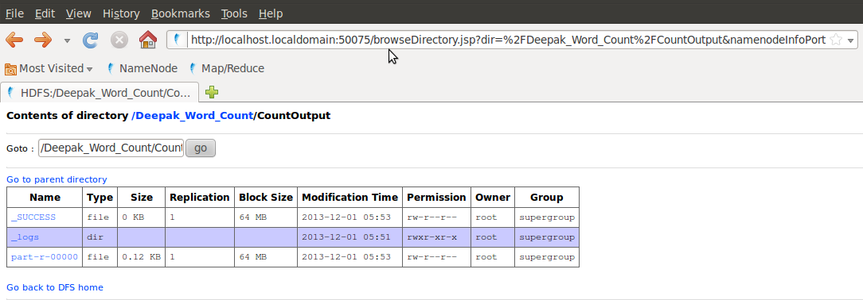

root@ubuntu:/home/mrinmoy/Downloads/MapReduce# hadoop fs -ls /Deepak_Word_Count/CountOutput/
Found 3 items
-rw-r--r-- 1 root supergroup 0 2013-12-01 05:53 /Deepak_Word_Count/CountOutput/_SUCCESS
drwxr-xr-x - root supergroup 0 2013-12-01 05:51 /Deepak_Word_Count/CountOutput/_logs
-rw-r--r-- 1 root supergroup 122 2013-12-01 05:53 /Deepak_Word_Count/CountOutput/part-r-00000

root@ubuntu:/home/mrinmoy/Downloads/MapReduce# hadoop fs -cat
/Deepak_Word_Count/CountOutput/part-r-00000
good 4312
hadoop 4312
having 2156
is 4312
knowledge 1078
leader 1078
learn 1078
market 3234
now 2156
people 1078
the 1078
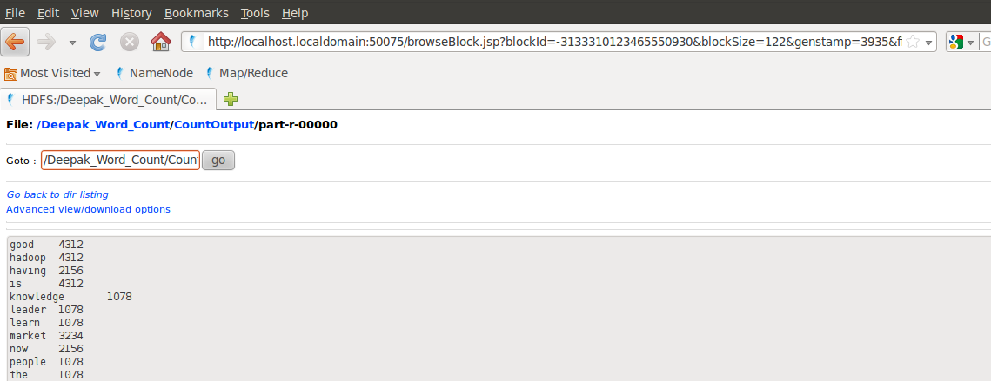
root@ubuntu:/home/mrinmoy/Downloads/MapReduce#

